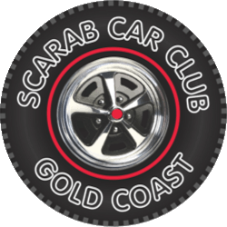

SCARAB Car Club Inc. Gold Coast QLD
Impromptu Individual Member Car Run.

This is to certify that the following activity has been recorded in the SCARAB Car Club Inc. (QLD) Official Program of Events
as an Impromptu Individual Single Run by the Member detailed below.

Name of Member _________________________________

Details of Vehicle _________________ REGO ________

Details of Event ______________________________________________________

______________________________________________________

Date / /

